
TCM3-Mifare
Mono Frequency RFID Card reader integrating NFC
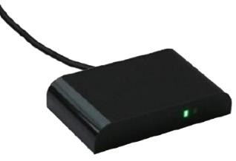

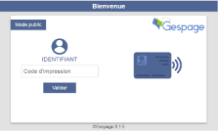



Available with:

With its small size and unique design, the Cartadis TCM3 is a reader for contactless or proximity cards. This single-frequency reader is optimized for managing 13.56 MHz MiFare technologies. It seamlessly emulates a USB keyboard, eliminating the need for driver setup on Windows PCs.
Application fields
Application fields
Enhanced print security: The TCM3 connects directly to the USB port of multifunction devices, facilitating user identification and secure print release (with Gespage Print2me function and other Pull Printing software solutions), copying or scanning tasks.

Option for the Cartadis cPad terminal: The TCM3 seamlessly integrates into the sleek design of the Cartadis cPad, providing seamless user identification through card usage with solutions like Gespage, as well as other print management software.

Streamline PC login: Say goodbye to password hassles! Just tap your RFID card to effortlessly access your PC, grant entry to specific applications, and seamlessly synchronize your card with user databases, whether they're on-premises or in the cloud.

Leverage RFID to improve the Retail experience: Connect the reader to your POS cashier system for seamless management of your loyalty program.

Go Beyond Standard: Tailor your TCM3 reader to seamlessly work with your specific RFID cards and USB protocols (OEM customisation).

TCM3: Application fields

MFP/Printer
PC
Touchscreen
Access
Time clock
Charger
Car park
Restaurant

- Identification with the NFC of an Android smartphone can be performed using the CartadisID mobile app available for free on the Apple AppStore and Google Play.

- The USB communication may be set, depending on the choice, in keyboard HID protocol or CCID.
- A configuration tool, standard supplied, enables transformation filters of the card identifiers to be installed.
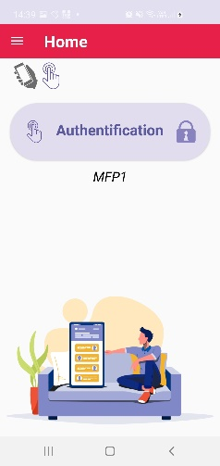
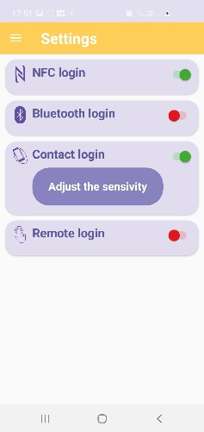
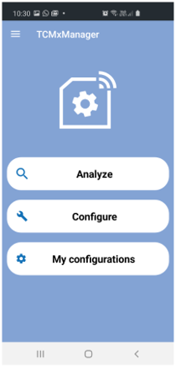
Identification using an Android or iOS smartphone is possible using the CartadisID application available for free on the stores.
This application allows you to select NFC and/or Bluetooth technology, click and/or contact identification.
Identification on iOS and click mode requires the Bluetooth option.
Application

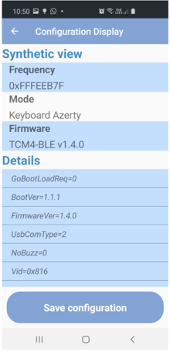
Ref: TCM3-125KHz EN 04/24. CARTADIS reserves the right to alter any feature and/or equipment without forewarning.
The TCMxManager configuration application supplied as standard allows you to very easily install the TCM4s, modify all the parameters and apply transformation filters for card identifiers.

TCMxManager runs on Android.
<
>

Specifications

Compatibility with cards for each TCM3 model (partial list):

- TCM3-Mifare (13.56 MHz)
. ISO14443-A: MIFARE (Classic, DESFire, A ATQA, Plus S, X, Pro X, Smart MX, Ultralight…), LEGIC Advant, iCLASS® SEOS (HID), (UID only)
.
. ISO18092: NFC, Sony FeliCa.
. ISO15693: LEGIC Advant (UID essentially) - Cartadis ID.
. HID USB Keyboard or CCID protocol.

sales@cartadis.com www.cartadis.com www.gespage.com

1, Avenue Louison Bobet - ZA des Marais - 94120 Fontenay-sous-Bois - France / Tél : (33) 01 48 77 40 60
TCM3-125KHz
Mono Frequency RFID Card reader integrating NFC

Available with:

With its small size and unique design, the Cartadis TCM3 is a reader for contactless or proximity cards. This single-frequency reader is optimized for managing 125 Khz technologies. It seamlessly emulates a USB keyboard, eliminating the need for driver setup on Windows PCs.
Application fields
Application fields
Enhanced print security: The TCM3 connects directly to the USB port of multifunction devices, facilitating user identification and secure print release (with Gespage Print2me function and other Pull Printing software solutions), copying or scanning tasks.

Option for the Cartadis cPad terminal: The TCM3 seamlessly integrates into the sleek design of the Cartadis cPad, providing seamless user identification through card usage with solutions like Gespage, as well as other print management software.

Streamline PC login: Say goodbye to password hassles! Just tap your RFID card to effortlessly access your PC, grant entry to specific applications, and seamlessly synchronize your card with user databases, whether they're on-premises or in the cloud.

Leverage RFID to improve the Retail experience: Connect the reader to your POS cashier system for seamless management of your loyalty program.

Go Beyond Standard: Tailor your TCM3 reader to seamlessly work with your specific RFID cards and USB protocols (OEM customisation).

TCM3: Application fields

MFP/Printer
PC
Touchscreen
Access
Time clock
Charger
Car park
Restaurant

- Identification with the NFC of an Android smartphone can be performed using the CartadisID mobile app available for free on the Apple AppStore and Google Play.

- The USB communication may be set, depending on the choice, in keyboard HID protocol or CCID.
- A configuration tool, standard supplied, enables transformation filters of the card identifiers to be installed.

Specifications
Compatibility with cards for each TCM3 model (partial list):

- TCM3-125 (125kHz/134.2kHz)
. EM4100, EM4102, EM4105, EM4200, EM4305, FDX-B, StartProx, Hitag 1&2, Indala, Biphase, Nedap, Pyramid.
Ref: TCM3-125KHz EN 04/24. CARTADIS reserves the right to alter any feature and/or equipment without forewarning.
- TCM3-HID (125kHz/134.2kHz)
. HID DuoProx II, HID ISO Prox II, HID Micro Prox, HID ProxKey III, HID Prox, HID Prox II.
- Fitted with Led light indicators and a buzzer for power-on and reading.
- The interface operates up to 10cm (according to the transponder).
- Dimensions: L = 80 mm; H = 50 mm; Depth = 15 mm; Weight = 50 g.
sales@cartadis.com www.cartadis.com www.gespage.com

1, Avenue Louison Bobet - ZA des Marais - 94120 Fontenay-sous-Bois - France / Tél : (33) 01 48 77 40 60

